ABLEISM?
LET’S TALK ABOUT IT
A Guide to Understanding and Dismantling Ableism

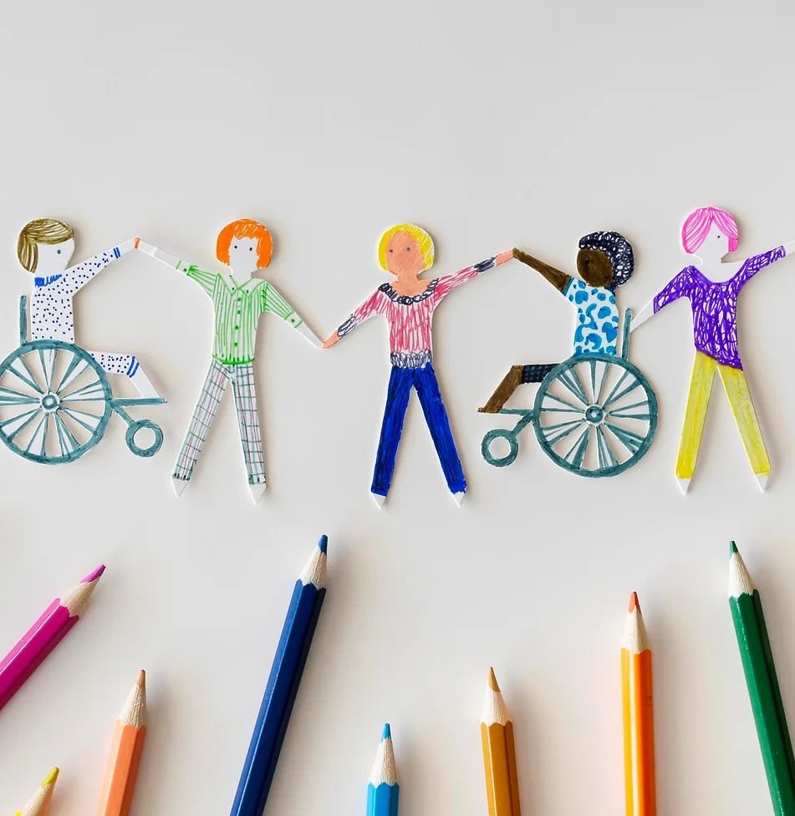




TERRITORIAL ACKNOWLEDGMENT
In this guide, we start by acknowledging the land we are on. Canada is home to many Indigenous Peoples, including First Nations, Inuit, and Métis. Long before others arrived, these communities lived on and cared for this land. Recognizing this is a step toward respect and understanding, reminding us of the ongoing relationship between the land, its original caretakers, and all of us who live here now. We honour this history and work towards a future that respects these truths.

WHAT WE NEED TO KNOW ABOUT ABLEISM
The purpose of this guide is to help people recognize ableism and take steps to dismantle it. The authors hope to:

- Show how real experiences of ableism impact the daily lives of people with disabilities by sharing their stories. These real-life stories are an important way of making ableism easier to recognize.

- Provide suggestions that will help people move from thinking about ableism to undertaking action that can both make a difference and maintain respect for everyone.

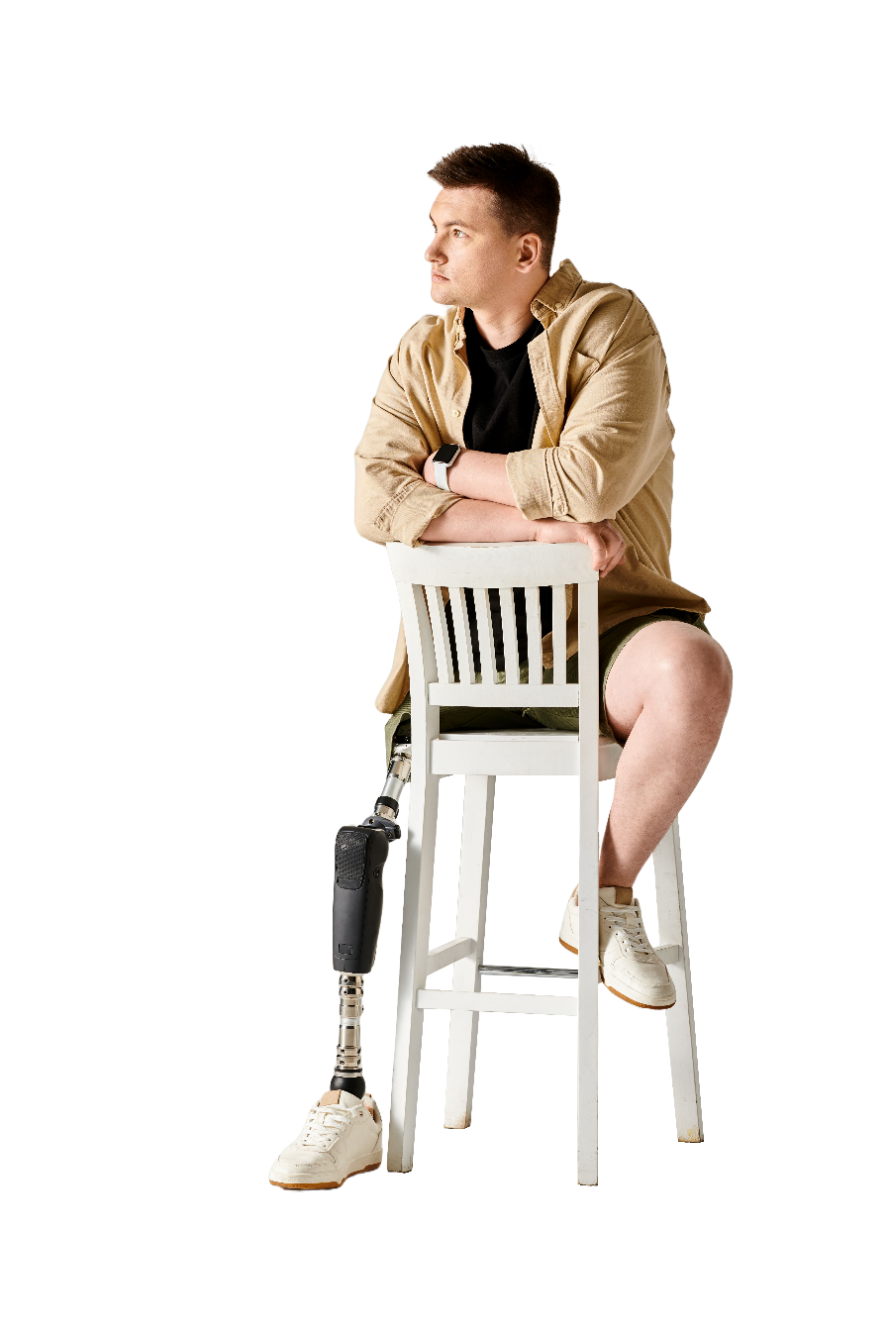
- Provide specific strategies and tactics that can help others recognize and dismantle ableism.

This guide is for anyone who wants to learn more about ableism. This can include politicians, teachers, workers, leaders, friends, and people with disabilities themselves. Ableism is present in most workplaces, schools, and in our community. This guide shares some first steps for those who want to begin to identify and remove barriers. It is also for people who want to make sure policies, practices, and interactions ensure everyone can participate fully in their community and feel valued and respected by community members.

EDUCATION
THE FIRST STEP
The first step is to learn about ableism, the second is to learn how to recognize it, and the third step is to dismantle it. It will soon be evident that ableism is a big problem and that people with disabilities can experience it everywhere. Once we recognize it, it becomes important to take steps to dismantle it.
Making changes can be difficult. Some people do not want to make changes as it is easier to do what has always been done. But once we understand that our actions might mean that we are preventing people from participating, it becomes clear that change is necessary.

WHAT IS ABLEISM?
Ableism can be defined as discrimination against disabled people in favour of people who do not have a disability. Yet, this basic idea does not fully consider how ableism affects people’s lives. It can make it difficult for people with disabilities to participate in school, jobs, or community activities. Ableism is based on the belief that people with disabilities cannot do certain things because of their physical, cognitive, sensory, or other “impairment”. This way of thinking incorrectly assumes that having a disability means you cannot do certain jobs or participate in specific activities in society. It also unfairly places responsibility on people with disabilities to overcome these challenges to belong. It values people based on what is seen as “normal” or “best”. Ableism doesn’t challenge communities or places to become more welcoming and accessible. Instead, it suggests, and sometimes demands, that people with disabilities should try to act as “normal” as possible to fit in. It puts the blame for inaccessibility on the person with the disability. When we recognize ableism and remove the barriers it creates, we acknowledge that everyone deserves to be included and valued for who they are.

REAL LIFE EXAMPLES

The following stories come from people with disabilities who have to deal with ableism everyday. These stories illustrate what ableism looks like in real life. After each story, there is an explanation of the profound effects of ableism. Ableism is often unrecognized but can have a significant impact on a person’s life.

JACKIE’S STORY
Throughout my life, I’ve faced many challenges because of how people view my disabilities. After years in the military, I struggled with Post Traumatic Stress Disorder (PTSD), but doctors didn’t believe me because I was doing well in other areas of my life, like school and my job. This made it hard for me to get the help I needed right away.
I also showed signs of Attention-Deficit/Hyperactivity Disorder (ADHD) and Autism Spectrum Disorder (ASD), but doctors didn’t take these seriously for a long time because I seemed to manage my life okay. I have a severe hearing problem, but I often just say I’m “deaf” to make it simpler for others to understand. Recently, I tried to join a group for disabled people, some doubted I belonged because I didn’t look the way they expected a disabled person to look. This taught me that people are slow to recognize disabilities that aren’t visible.


IDENTIFYING ABLEISM IN JACKIE’S STORY

- Not Believing that PTSD, ADHD, and ASD can be serious and can Differ for Everyone:
If a person with a disability does well in one part of their life, some people think that their disability is not really a part of them that requires support. This is wrong, and it ignores the fact that even the same life experience can affect people differently. It is like saying you can only be disabled if everyone can see you struggling, and that everyone who has these experiences does so in the same way. It essentially says that only the abled person can decide who is disabled.

- Having to simplify being Hard of Hearing for Others:
Saying “I’m deaf” to make things simpler, and possibly more comfortable, for others shows that people do not always understand what it is like to live with significant hearing loss. It is an example of how people overlook the real and varied experiences of those with hearing disabilities and make false assumptions about what hearing loss is and is not.
- Having to “Look” Disabled to Feel Like You Belong:
When Jackie felt like they did not belong because they did not look disabled, it highlighted a common assumption that a disability must be visible or apparent for it to be considered “real”. This is false, and it leaves out many people who have disabilities that are not visible or apparent or that are episodic.

- Basing Support Decisions on How Obvious a Disability is or is not:
If a disability is not immediately apparent, people tend to believe it is either imagined or unimportant. This means some people do not get the support or understanding they need because their disability does not match what others have come to assume disability looks like.

In all these situations, Jackie faced ableism because people made unfair and inaccurate assumptions about their abilities and needs. It is important to listen to and believe individuals’ experiences and understand that disabilities can look and feel different for everyone.

GUILDA’S STORY
I’m Guilda, and when I was in my early 20’s, I found out I have a chronic illness. This means I have to watch my health at all times. I visit the doctor often and sometimes need to go to the hospital without warning. I take several strong medications and try different treatments to keep my illness under control.
Dealing with this has not been easy, and most of the time, I try to handle it by myself. When I have tried to tell people about my illness, it does not always go well. They mean well, but they do not really understand. They might say, “Oh, I’ve been sick like that before. Here’s what I did to get better.” But my illness isn’t something that just goes away like a cold or flu. It is a big part of my life and affects everything I do. When people compare it to something small, it feels like they are not taking it seriously.



IDENTIFYING ABLEISM IN GUILDA’S STORY

- Minimization of experience
The reaction Guilda receives when she tries to discuss her chronic illness—”Oh, I’ve had that...”—is an example of ableism because it minimizes and invalidates her lived experience. Comparing a chronic, potentially debilitating condition to a common, temporary ailment overlooks the severity and complexity of chronic illnesses. This minimization can make individuals feel unseen and misunderstood, compounding the emotional toll of their condition.
- Feeling a Need to Isolate to Cope
Guilda chooses to deal with her health issues alone because of these misunderstandings and the related attempts by others to offer “cures”. The ableism she faces is a result of common beliefs about a person’s responsibility to do everything they can do to “get over” something that is not curable. Misunderstanding leads to false connections between minor or temporary illness and chronic conditions; and it also leads to constant questioning from those who underestimate the difficulties that chronic illness produces. The result of having to constantly answer questions and having to justify why you aren’t “getting better” is that people simply choose to cope in silence which leads to social isolation.

Guilda’s story shows us that there are real-life consequences for people when we do not try to understand what it is like to live with a chronic illness. Some try to help by comparing it to getting over a temporary illness which simply conveys that we want them to get better quickly, or we don’t want their health needs to impact us. This kind of response tells Guilda that she is expected to cope with her illness alone, and it minimizes her real, everyday challenges. Her story teaches us that we need to listen and understand when someone talks about their chronic illness, instead of just offering quick fixes. It is important to remember that being supportive means acknowledging that their illness impacts every aspect of their life. It is not something that we can or should expect can be easily fixed.

RAJIV’S STORY
I’m Rajiv, I use a wheelchair, and I’ve always dreamed big, especially about welding. I love the idea of turning metal into art with precision. But my path to chasing this dream was not easy, and the main problems were not about my wheelchair. They were about how people thought about what I could or could not do.
In school, some teachers did not believe in me. They said they were worried about my safety in welding, saying things like, “I’m worried you might hurt yourself.” It sounded like they cared, but really, it felt like they thought my disability meant I could not do anything risky. They did not see that I could learn safe ways to weld that fit my situation.
When we talked about future jobs, it got tougher. One teacher told me flat out that a person in a wheelchair could not work in welding, especially not on a construction site. That hurt because it felt like they were saying my dreams did not matter because of my wheelchair. But I knew my passion and skills mattered more than their doubts.


IDENTIFYING ABLEISM IN RAJIV’S STORY

- Underestimating Rajiv:
Rajiv’s teachers assumed that he could not safely participate in welding because of his disability. Ableism led his educators to assume that any limitations were based only on his wheelchair use. It also led them to assume that adaptations to, or supports within, the job environment were not possible.
- Actively Discouraging Rajiv:
Ableism often leads to assumptions about who can and cannot do specific jobs, and telling Rajiv that people in wheelchairs cannot work on construction sites is a clear example of this ableist assumption. It disregards his passion and potential by saying that disability is the only barrier, rather than asking how barriers can be removed by modifying the worksite and providing disability support.

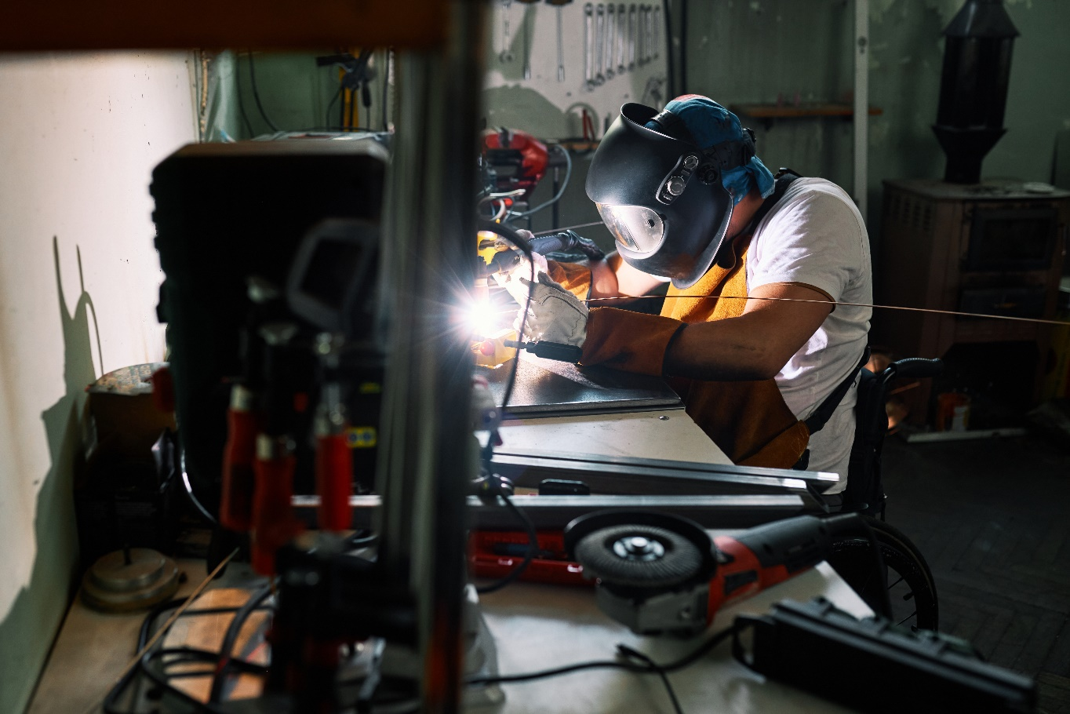

This example highlights how people with disabilities encounter societal and systemic barriers, not because of their own limitations, but because of the beliefs and perceptions of others, a lack of accessibility or appropriate adaptation and support, and a failure to acknowledge the potential of people with disabilities.



NICOLE’S STORY
I’m Nicole, and I am a university student in my third year of a degree in business. I am neurodivergent and have a diagnosed learning disability, and I struggle every year to have approved academic accommodations implemented in my classes. The people who are supposed to be providing disability support keep asking for additional proof that I need accommodations, and getting the documents they require is expensive and means that I need an appointment with a professional that might not be available for six months.
My professors say they are supportive, but they keep forgetting to send my tests and exams to the space where I write so I can have extra time. They also say they worry about whether my extra time on exams or extended deadlines for assignments is fair to other students. They eventually send my tests and exams to the space where I will write, but their delays cause a lot of stress that makes it hard to focus when I finally begin to write the exam. They do respect my extended assignment deadlines, but their comments about fairness to other students makes me feel guilt and shame, and that makes me consider not using the accommodations that are, in fact, my right.
Disability services requires that I register for exam accommodations two weeks before every test or exam, and if I miss the deadline which sometimes happens because organization is a significant area of difficulty with my learning disability, they refuse to organize my accommodated exam. Even if I do register on time, they sometimes book the exam in a place that is already being used, so I have to wait until they can arrange another space and then transition to that space before I can begin to take my test or exam.

IDENTIFYING ABLEISM IN NICOLE’S STORY

Requiring Repeated Proof of Disability as a Condition of Support
Ableism leads people to assume that students with disabilities only need learning support, or academic accommodations, if a professional says they do. Requiring a professional report to verify a disability before a student can receive accommodations, such as additional time to write an exam, means students can wait a long time for accommodations to be implemented. It also means their learning and achievement are jeopardized. It ignores the fact that most impairments are permanent, and it does not recognize that requiring a lot of extra work to organize accommodations takes time away from learning.
Assuming that Accommodations are Unfair to Abled Students
Ableism leads people to believe that the longer it takes a person to share what they have learned, the less they have learned. It also leads people to assume that extra time to complete a test or exam gives a student with a disability an unfair advantage over abled students while failing to recognize that timed tests and exams advantage individuals who process and communicate material quickly. These assumptions incorrectly equate speed of communication with how much a student has learned, and they tell students that it is more important to be able to share what you know quickly than to be able to share what you know completely.

Denying an Accommodation if a Registration Deadline is not Met
Many students who require, for example, test and exam accommodations must register the dates and times of their exams with accessibility services by a specific deadline. If they do not do this, the accommodation may be denied. It is true that time is required to make arrangements, but ableism leads people to impose conditions that ask students with disabilities to adopt a level of task organization that a professional assessment has already said is difficult for them and that, therefore, requires an accommodation. For a student, it can feel like they are being punished for something they can’t change about themselves; and the punishment is denial of the chance to share what they have learned with the professor.

Failing to Provide Tests and Exams to Alternate Test Spaces on Time
Ableism leads people to prioritize test and exam arrangements for students who will write exams accommodations. It leads people to approach adapted exam arrangements as additional, and sometimes less important work; and it leads people to ignore the stress that failing to provide the exam on time can create for a student with a disability. When a student knows they need additional time, and that additional time has been scheduled with specific start and end points, having to wait for the test or exam to arrive at the testing site means they know their additional time will be reduced and that their opportunity to share what they have learned is being jeopardized.

Regularly Making Errors in Exam Accommodation Scheduling
When a scheduling conflict happens regularly, and a student shows up at the designated room only to find it is already in use, a lot of additional stress is created. If their accommodated exam period is for two hours and they have a class right after their exam, a scheduling error means they will have reduced time to write the exam because a new room must be found. Alternatively, it means they must miss the upcoming class and risk the response from that professor for missing a class. Ableism leads people to minimize the impact of these mistakes on students’ academic achievement and on their overall well-being. The fact that there is generally a process in place for abled students to view their exam schedule and report scheduling conflicts in advance suggests that resolving these conflicts is known to be important. Yet, there is no process for students with disabilities to ensure there are no conflicts in advance, and this suggests the impact of the conflict on students with disabilities is deemed less important than the impact of conflicts on abled students.


INTERSECTIONALITY
WHAT IT IS AND WHY WE NEED TO CONSIDER IT

The barriers people with disabilities face are shaped by numerous factors, not just by responses to their impairments. Their experiences of inaccessibility and discrimination are often complicated by ways that beliefs about disability are linked to beliefs about other aspects such as gender identity and expression, race, socioeconomic status, sexual orientation, cognitive capacity, and place of birth. Yet, people with disabilities are expected to focus only on impairment or disability, for example, when trying to access disability support services. As a result, they are often forced to disregard other aspects of their identity and all the ways people respond to those aspects of their identity. This ignores how ableism, racism, and sexism are intricately linked with the health, life, education, and employment experiences of individuals with disabilities. It also disregards the fact that Indigenous perspectives on disability, for example, can differ quite significantly from government definitions of disability. This can make it difficult to meet set criteria, and then, qualify for support that will enable them to live, learn, and work as a person with a disability in Canada. By acknowledging intersectionality, we can better understand the unique challenges faced by disabled individuals who may also belong to other marginalized groups.
- Kimberlé Crenshaw on Intersectionality – The Big Idea

WHERE ABLEISM SHOWS UP
Identifying ableism in our daily lives means we need to look carefully at the many ways it shows up in various aspects of society. It has been described as being everywhere and nowhere because it is often hidden. So, we need to pay attention to be able to recognize it and dismantle it.
Presumptions of Inability or Incompetence: Ableism most often shows in the ways we make assumptions about what people can or cannot do because of an impairment. This assumption undermines the fact that people with disabilities have a wide variety of strengths and potential, and it leads to exclusion and marginalization. Ableist presumptions of incompetence or inability are also linked to beliefs that specific abilities are required to complete a particular task or job. Ableism also leads us to assume that there is one “best” way to complete that task or job and that doing it differently won’t work. Ableism, in this case, shows up when we fail to consider that there is usually more than one way to complete the task or job and that each way is equally valid.
Planning for “Regular” Students First: In a wide variety of educational settings, ableism leads people to plan for “regular” students first. It leads people to plan curriculum, choose learning materials, and use teaching strategies that work best for “regular” students but that can often be hard for students with disabilities to engage with or learn from. This means using inaccessible learning materials (text-based materials that are not available in accessible digital formats or video materials with no captioning) and using learning environments that are not accessible to people who live with physical, cognitive, and sensory disabilities. Furniture that is fixed to the floor and the lack of a ramp or elevator means students who use wheelchairs or other mobility devices might not be able to participate. Classrooms that are highly visually and auditorily stimulating can make it impossible for autistic and neurodivergent students to be present and learn. Ableism also leads people to design exam schedules, timetables, course requirements, technology requirements, and due dates that are inflexible which can mean students with disabilities find it impossible to meet rigid expectations.
Discrimination in Healthcare: People with disabilities might encounter medical professionals who are not trained to address their specific needs or who hold biases that affect the care they provide. This can result in misdiagnosis, inadequate treatment, or dismissive attitudes towards the concerns of disabled individuals.

Legislation and Policy: Although many laws try to protect the rights of people with disabilities, ableism can be found in an unwillingness to enforce the laws. Often, bureaucratic hurdles make it difficult for those with disabilities to claim their rights or access necessary services and supports, even when they are supposed to be protected by legislation or written into policy.
Technology and Digital Accessibility: As technology becomes more integrated into daily life, the digital divide for people with disabilities widens when websites, applications, and digital devices are not designed with accessibility in mind. This limits access to information, services, and opportunities for participation in society by assuming only people without disabilities require such access.
Inaccessibility and Discrimination at Work: Employment discrimination is a significant issue for people with disabilities who often encounter barriers in hiring processes, opportunities for promotion, and the outright refusal to provide workplace accommodations. Ableism leads people to expect, and sometimes demand, people to perform job tasks in one specific way. It can also mean that people refuse to be understanding of disability-specific realities or to willingly modify work environments or schedules to meet the needs of employees with disabilities.
For example, requiring all employees to work strict 9 to 5 hours without considering flexible scheduling options can be particularly challenging for individuals with chronic illnesses, mental health conditions, or those who require regular medical appointments. This inflexibility fails to accept the diverse health needs and life circumstances of a diverse workforce.
Stereotypes in Media: Media and other types of entertainment like movies, social media, or television, often portray individuals with disabilities using inaccurate or overly simplified stereotypical portrayals (blind people are musicians, autistic people are relationally incompetent but brilliant scientists, wheelchair users are inspirational). Ableism often leads people to portray disabled people as inspirational because they have overcome their disability, not because they are genuinely valued for their contributions and achievements. These stereotypes perpetuate harmful perspectives about people with disabilities and the lives they live.

Inaccessible or Exclusionary Built Environments: Physical spaces and built environments are often designed for people who use and move through them in standard ways (using their eyes, ears, and their legs). This is a demonstration of ableism that can be very exclusionary because the cost of making a space accessible is used as a reason to ignore the human cost of exclusion and isolation. Designing buildings that have ramps and elevators, for example, is less expensive and ensures accessibility for wheelchair users. However, ableism leads people to expect and plan only for standard users of the building which can make it impossible for people with a variety of disabilities to use and feel included in public spaces that should be for everyone.
Non-sensory-friendly environments are also a result of the ableism that leads people to plan only for standard users. They typically refer to spaces or situations that can be challenging for individuals with sensory processing issues to occupy. They are spaces and places where the level or type of sensory input (like noise, lights, or crowds) can not be adjusted to help the people who may be sensitive to, or overwhelmed by such triggers. This can include bright flashing lights, loud or unpredictable sounds, strong odors, or require close physical proximity to others which can lead to discomfort, anxiety, or sensory overload.
Microaggressions: These are subtle, often unintentional, expressions of ableism that can be hurtful and demeaning. Examples include questioning the legitimacy of someone’s disability, using derogatory language, or expressing surprise at a disabled person’s achievements.
Types of Microaggressions:
• Verbal - Comments or questions that subtly belittle the experiences or abilities of individuals with disabilities.
• Actions - Actions that exclude or demean those with disabilities, such as speaking louder and more slowly to a person with a physical disability, assuming they also have a hearing impairment or cognitive disability. Also, assisting a person with a disability without asking first if they require assistance is a microaggression. Ignoring a person with a disability, talking over them in a group conversation, or asking their abled friend or partner what they would like says that you assume they are not able to understand, participate, or speak for themselves.
• Environmental – Ableism in the built environment occurs when it excludes people with disabilities. This happens when we organize events in non-accessible venues which makes it obvious that the participation of people with disabilities was not considered or valued.
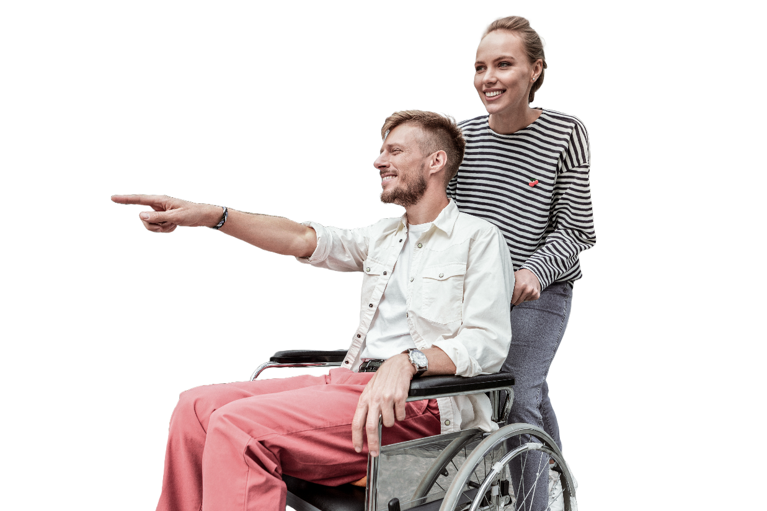

WHAT CAN I DO TO DISMANTLE ABLEISM
This guide is all about helping people who have not had the opportunity to learn about how to identify and dismantle ableism to find a place to start. Ableism, which repeatedly tells disabled people that society would prefer them to be “normal”, makes life hard for people with disabilities. The following are some suggestions to begin the process.

Review Policies and Practices – Carefully review policies and practices to identify ways they might prevent people with disabilities from participation and achievement. Are your policies and processes flexible? For example, do you send invitations using graphics with embedded text that blind people who use screen readers cannot access? Does your website use a lot of flashing words and images that might make it impossible for autistic people to read or engage? Are entrances to buildings and washrooms accessible for a wide variety of participants? Do your event invitations ask about disability-specific or accessibility requirements such as accessible document formats, sign language interpretation, accessible parking, etc.? A successful event is one everyone can enjoy.
Ensure Representation of People with Disabilities – Any policy or practice you write or design should involve and consider the perspectives of people with disabilities. Their expertise will help you design inclusive and accessible policies, practices, and spaces.
Develop Flexible Procedures – One Size Does Not Fit All - Are procedures so rigid that they cannot be adapted to those with disabilities, for example, work hours, standardized testing, etc.? Do your procedures make assumptions about what people with disabilities can and cannot do? Do they send the message that there is only one right way to work or only one acceptable work schedule? Review all procedures and try to build in flexibility so a diverse array of people can participate, learn, grow, and advance in their careers.

Ensure inclusive education is adequately resourced – Segregating students with disabilities from their abled peers can limit their engagement with the curriculum and access to learning. It is important to advocate for funding and resources to ensure schools and educators can provide appropriate curriculum access, learning support, and extracurricular options for students with disabilities. Educators must receive and be supported to implement accessible teaching practices. Students should not have to prove that they have a disability to receive learning support, especially when the education system is not accessible or inclusive. It should never be the student’s responsibility to ensure the system is accessible.
Ensure Accessibility in the Built Environment – Policies and practices related to the built environment, which includes indoor and outdoor spaces, must ensure that new construction or renovations are accessible to those with disabilities and should account for a diversity of disabilities, not just wheelchair use. It is important to maintain the same expectations for accessible outdoor spaces (parks, playgrounds etc.) as you would for indoor spaces.
Ensure employment Equity for People with Disabilities – Employment policies should ensure that people with disabilities are treated equitably in the workplace. It is unacceptable to pay a person with a disability less than their abled counterpart. It is also vital that employees have access to the same opportunities for promotion and advancement as their abled counterparts. Workplaces need to ensure they provide reasonable accommodations such as flexible work hours, telecommuting options, accessible software, or physical adjustments to ensure people with disabilities can participate and flourish.
Ensure Accessible Digital Communications and Platforms – Policies and processes need to ensure that websites, digital platforms, and online services be accessible to individuals with disabilities, including those who use screen readers and alternative navigation tools. Consult the Web Content Accessibility Guidelines to ensure your digital content and platforms are accessible for all. Do not assume that only abled people will use your materials and websites.


Offer Training on Recognizing and Dismantling Ableism – Workplaces and organizations should offer training about ableism, what it is, how it appears, and how to dismantle it. This training should be required for individuals who work in leadership or with people. This training will ideally be facilitated by people with disabilities. Topics might include awareness of disability rights, exploration of common ableist attitudes, identification of exclusive practices, examination of language and how it can cause harm, and exploration of other participation barriers.


Language matters
When we talk, we sometimes use phrases without thinking about how they might make others feel. Phrases like "blind to the facts" or "falling on deaf ears" can be offensive and even ableist because they equate disability with inattention or willful ignorance. These common sayings contribute to existing beliefs that disability is bad, and it ignores the fact that people with disabilities live full, rich lives.
Choosing Better Words
Choosing our words carefully means we respect everyone. For instance, instead of saying someone is “confined” to a wheelchair, we can say they “use” a wheelchair. This small change shows that a wheelchair helps someone move around freely, which is a good thing, not something that holds them back.

Person First or Disability First Language

Some people like to say “person with a disability” because it puts the person first, not the disability. But not everyone likes this way of speaking. Some prefer to say “disabled person” because they feel their disability is an important part of who they are. What’s most important is to respect the choice that each person makes for themselves. There’s no single right way to talk about someone’s disability. The best approach is to listen and use the words they prefer. By becoming aware of and actively challenging these manifestations of ableism, we can work towards creating a more equitable and accessible world for everyone.

MAIN POINTS TO REMEMBER
- Listen and Believe: People with disabilities have important information about our schools, workplaces, and communities. Their experiences and wisdom can help us create accessible and welcoming places and spaces. Do not devalue disabled peoples’ stories. Their experiences can teach us about living well and flourishing with a disability.

- Move from Thought to Action: Learning about ableism, what it is, and how it shows up in everyday contexts is important. However, action that leads to change is where real progress happens.

- Dismantling Ableism is Everyone's Responsibility: Creating a society that is free from ableism is everyone’s responsibility. See it, recognize it, do something about it.

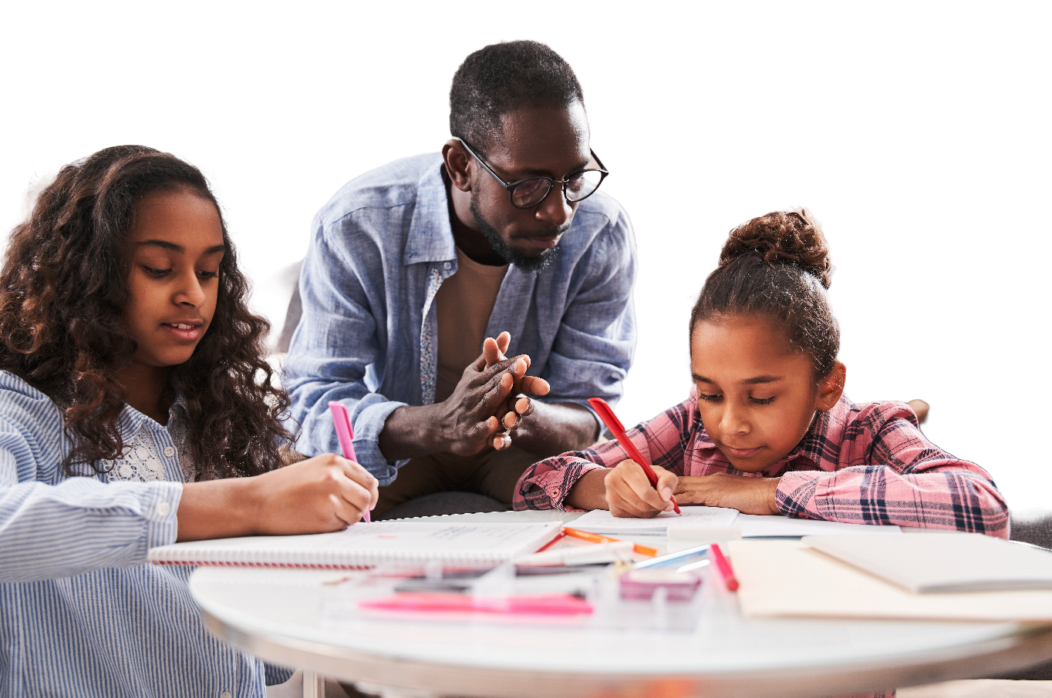

LET’S LEARN TOGETHER
Education is our starting point. This guide introduces real stories from people who live with ableism and the harms it creates every day. Understanding their experiences helps us see the importance of fighting ableism.

FURTHER READING AND RESOURCES
- "Disability Visibility" by Alice Wong: A collection of firsthand accounts from people with disabilities, sharing their experiences and the diversity of disability.
- "No Pity" by Joseph P. Shapiro: Offers an overview of the disability rights movement and challenges common misconceptions about disability.
- The ADA National Network (adata.org): Provides information, guidance, and training on the Americans with Disabilities Act (ADA).
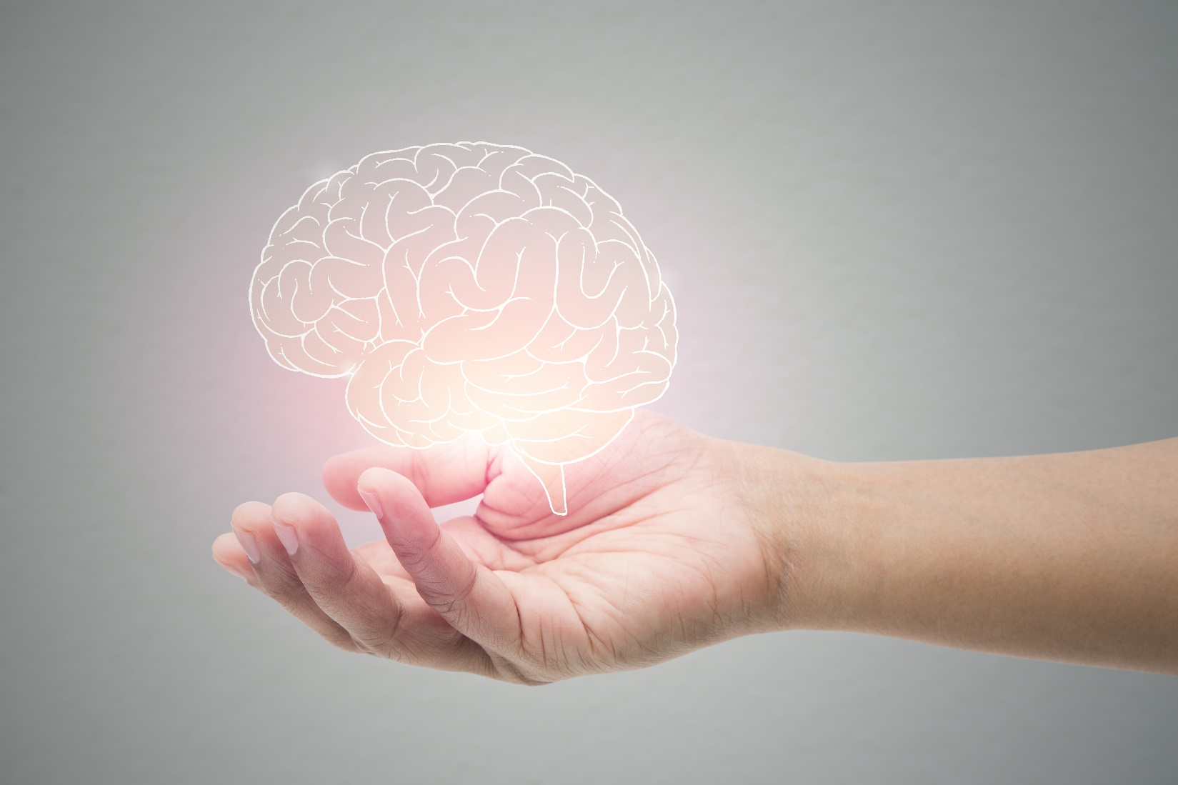

AUTHORS OF THE GUIDE
Cynthia Bruce
Dr. Cynthia Bruce is a blind activist. She has worked in post-secondary accessibility and currently teaches and researches accessibility and higher education at Concordia University. She recently worked as Vice-Chair of the Nova Scotia Education Standard Development Committee which submitted a comprehensive set of accessibility standard recommendations to the Government of Nova Scotia.
Maureen Wideman
Dr. Maureen Wideman has been working in postsecondary education most of her career, most recently as an administrator at the University of the Fraser Valley in British Columbia. A focus over the last 30 years has been to create accessible learning environments and inclusive teaching practices. She lives with a chronic disease, an invisible disability. She is active in accessibility committees locally and nationally.
Rana Elchamaa
Rana Elchamaa works with the Canadian Accessibility Network and is passionate about making the world more welcoming and understanding for everyone, especially people with disabilities. She studied Neuroscience and Mental Health at Carleton University, where she is now working towards another degree in Psychology. This has helped her learn a lot about how our brains work and how we think and feel.

About The Canadian Accessibility Network (CAN) And the Education And Training Community Of Practice (CoP)
The Canadian Accessibility Network and its Education and Training Community of Practice (CoP) work with people across Canada to make life better for people with disabilities. It is a group of people who learn from each other and engage with each other to work towards solutions for a world where everyone is included and treated fairly, no matter their abilities. This organization includes people with disabilities, their friends and supporters, and experts who all believe in making a difference and creating a world where every person is enabled and encouraged to reach their maximum potential as a contributing member of society.

ABLEISM?
LET’S TALK ABOUT IT
A Guide to Understanding and Dismantling Ableism

